**Task-1 : Cloud Storage Setup**

**CREATE AND CONFIGURE CLOUD STORAGE ON AWS S3 OR GOOGLE CLOUD STORAGE.**

**DELIVERABLE: A BUCKET SETUP WITH EXAMPLE FILES UPLOADED AND ACCESS**  **PERMISSIONS CONFIGURED**

**Creating an S3 Bucket**

# Go search S3 bucket → click on it → click create bucket

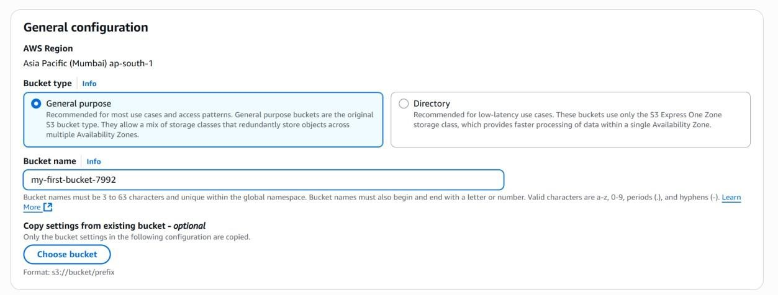

# Give a unique name for the bucket, make sure that your name is having some numbers(ID)

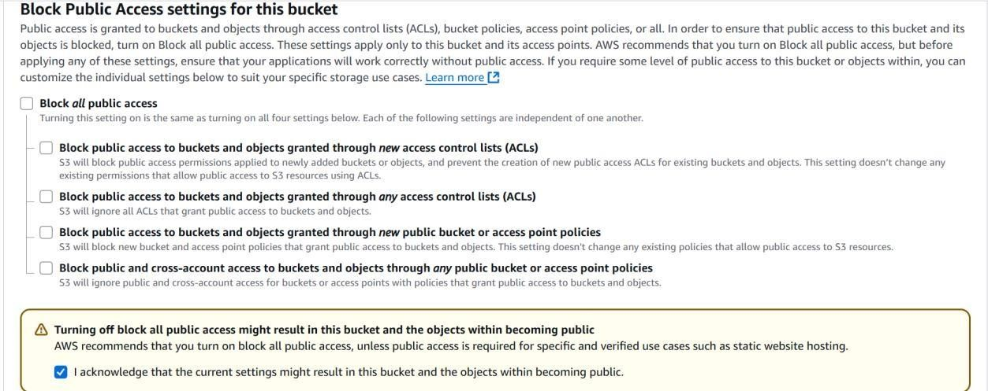

Uncheck the “Block all public access” and check the acknowledgement.

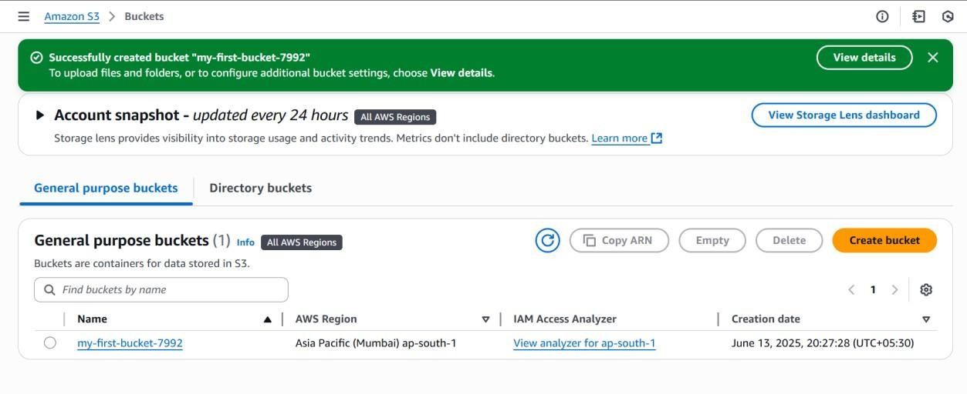

Bucket created

**Uploading File and giving permissions**

# Uploading the file

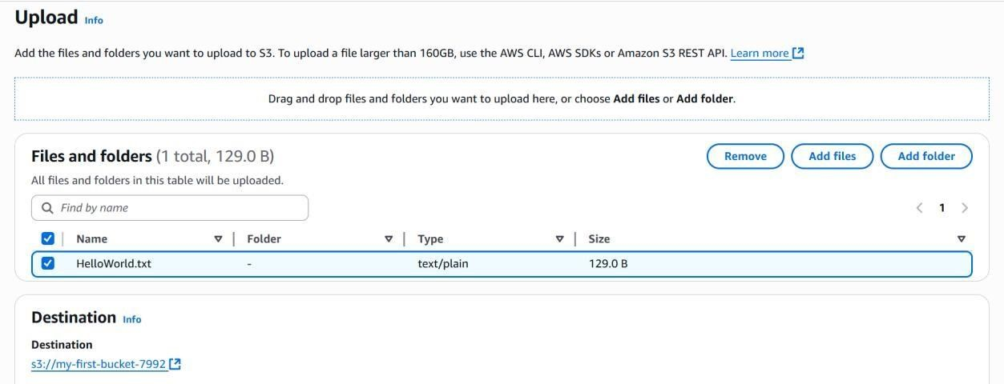

# click add files → add the file → select the file you want to upload → click upload

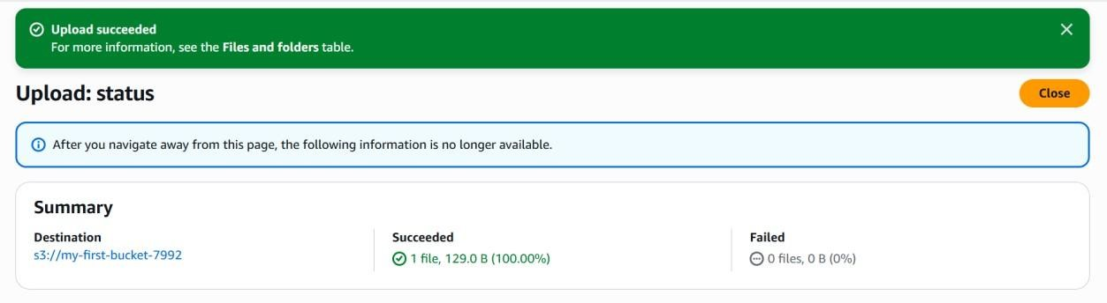

# File uploaded

Click on your bucket name → Go to permissions.

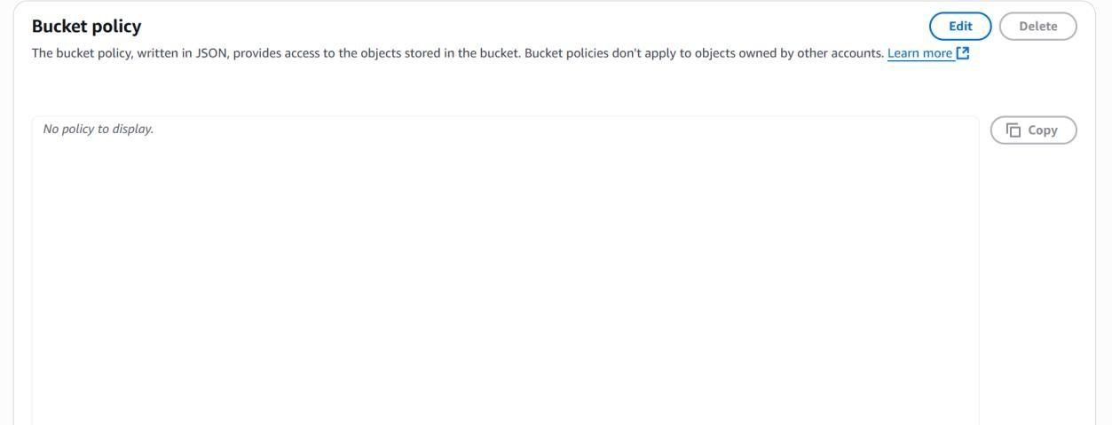

# now click edit → copy this json code down below

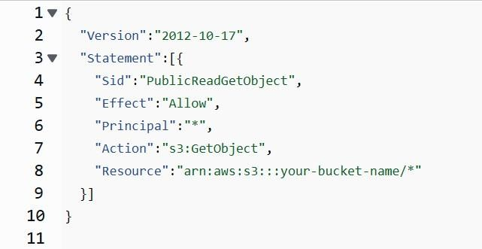

This code will only give a read permissions.